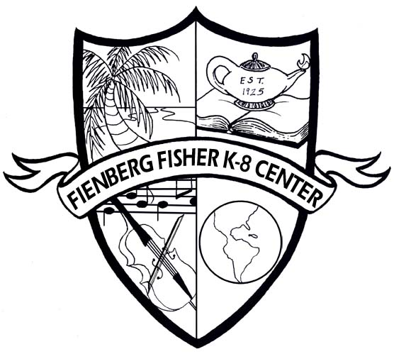
6th Grade Language Arts
Fienberg-Fisher K-8 Center
6th grade Summer 2013 Reading List

Incoming sixth graders must read two novels below assigned by the Reading/Language Arts Department. Students are also required to select and complete ONE of the projects for each of the novels. Novel selections are determined by the grade level and IB program and recommended by the 6th grade teacher.

The Revealers by Doug Wilhem
Choose ONE of the following projects. This project is a REQUIRED assignment. Projects are due the first week of school.
Option #1: Select captivating quotations that you can use to persuade a prospective reader to choose The Revealers. Create a book jacket and incorporate the quotations. See Directions below.
Option #2: Think about a time that you were bullied or bullied others. Compare your experience with bullying to the characters in the story. How are your stories similar and different? How was your bullying situation handled compared to characters? Draw a poster size Venn diagram depicting a comparison and contrast between your bullying experiences to the characters’.
Option #3: Select captivating quotations that you can use to persuade a prospective reader to choose The Revealers. Create a book jacket and incorporate the quotations. See Directions below.

Al Capone Does My Shirts by Gennifer Choldenko
Choose ONE of the following projects. This project is a REQUIRED assignment. Projects are due the first week of school.
Option #1: Alcatraz was used as a prison from 1934 to 1963, but it was built long before that. Write at least a two-page research paper including its previous use, why it was chosen to be a high security prison, how the prison was run, people who were imprisoned there, prisoners who escaped, and any other interesting information. Your information should include a map of the area.
Option #2: Write an ad in the paper for a job at Alcatraz. Include the description of the setting based on what you have learned from the story. Also include other jobs descriptions that you think might be necessary at Alcatraz.
Option #3: How would you feel if you were in Moose’s shoes? What would you like most about living at Alcatraz? What would you like least? Why? What do you think happened after the story ended? Create the next chapter for the reader.

Number of the Stars by Lois Lowry
Choose ONE of the following projects. This project is a REQUIRED assignment. Projects are due the first week of school.
Option #1: Write a physical, emotional, and relational description of two characters from Number of the Stars. Add a portrait to go along with your description.
Option #2: Create a timeline including illustrations of the events from Number the Stars. Include a map showing the locations of where the story took place and descriptions of the events that occurred.
Option #3: Pretend you a reporter for the local newspaper in Europe during World War II. Your assignment as a reporter is to interview one of the characters in the story and their feelings and emotions during the war. When writing the article, please include the questions and answers that were provided by the character. Also include background of the story and the character.
Book Jacket Directions:
1. Look at a minimum of five examples of hardcover book jackets before beginning this project. (Go to a library or any bookstore)
2. Using construction paper of whatever color you wish, design a book jacket. Fold the paper like the picture below. Fold it like a real book jacket.
3. You may create your book jacket by using the computer, by hand or using a combination of both.
4. Design your book jacket so it includes the information generally found on a book jacket.
5. Be original! Be creative! Use color! Use your imagination! Have fun!

